Project ID: 11/H1102/8
Version: 6
Date: 11th March 2013

PATIENT INFORMATION SHEET

Part 1

FOCAL HIFU IN MEN WITH LOCALISED PROSTATE CANCER – THE ‘INDEX’ STUDY

You are being invited to take part in a research study. Before you decide whether to take part it is important for you to understand why the research is being done and what it will involve. Talk to others about the study if you wish.

- Part 1 tells you the purpose of this study and what will happen to you if you take part.

- Part 2 gives you more detailed information about the conduct of the study.

Ask us if there is anything that is not clear or if you would like more information. Please take time to decide whether or not you wish to participate.

1. What is the purpose of the study?

Main Aim of the Project
The treatment we are testing is destruction (or ‘ablation’) of only the part of the prostate gland containing ‘clinically significant’ (or ‘clinically important’) cancer. This is called focal therapy. The cancer areas requiring this treatment will be located by a special type of scan called Magnetic Resonance Imaging (MRI) and a special type of prostate biopsies called Template Prostate Mapping (TPM). The treatment will be carried out using high intensity focused ultrasound (HIFU). HIFU uses sound waves to heat and destroy tissue. We will use a HIFU device called the Sonablate® 500. The device is placed in the back passage and focuses an ultrasound beam across the wall of the back passage into the prostate. It can heat small amounts of tissue to within a few millimetres of accuracy to cause tissue destruction only in that area. This study will help us to find out what side-effects men get after focal therapy and how effective it is in cancer control.

Why is this trial needed?
Men who have prostate cancer that has not spread outside the prostate gland can choose to have a number of treatments. These include radiotherapy and surgery to treat the whole gland. HIFU is also used to treat the whole gland. In many men surveillance can be carried out as prostate cancer does not always need to be treated.

Men who have treatment to the whole prostate in any of the ways listed above have more certainty that all of the cancer is treated. However, treatment to the whole prostate can affect sexual function (poor erections), urine control (urine leakage requiring pads) and can cause back passage problems (bleeding, diarrhoea or pain). On average, 1 in 2 men suffer with erection problems (insufficient for penetrative sex), 1 in 10 has leakage of urine requiring pads and 1 in 20 has back passage problems after whole prostate treatment. In those men who have return of their erections and their urine leak stops, this can take between 12 and 18 months for full recovery. This is because the nerves, muscles and back passage are very close to the prostate and can get damaged. The diagram below illustrates the prostate and the closeness of different structures important for function.

Side View of the Prostate and Surrounding Structures
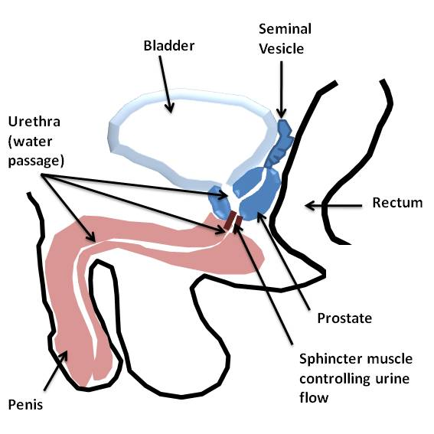

Some men are not suitable for surgery or radiotherapy or do not want to have the symptoms of whole-gland treatment. For these men surveillance can be an option. Surveillance involves watching the disease carefully and if it shows any signs of getting worse, one of the many treatment options is given.

The following diagram gives an overview of the treatment options that are available to men with prostate cancer. It is important you discuss which options are available and suitable for you with your doctors. This study will involve the treatment of men with low and medium risk disease only:

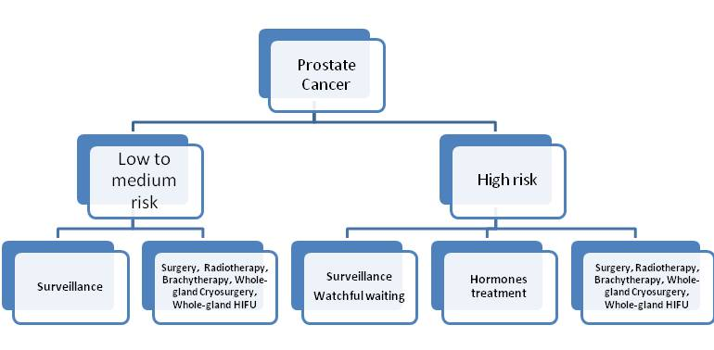

The difference between surveillance and whole-gland treatment in terms of reducing cancer-related deaths is very small. The difference in the number of deaths from prostate cancer at 15 years between watchful waiting (a type of surveillance) and treating the whole prostate is only 5%. This difference is likely to be smaller in men who are currently diagnosed with prostate cancer. This is because of two reasons. First, this study looked at men who had higher risk prostate cancer than we find in the present time (cancer was usually detected later when this study was done). In other words, cancer that is more likely to spread to other parts of the body and cause death. The difference for men with low to medium risk prostate cancer will most likely be lower than 5% at 15 years. Second, this study used watchful waiting rather than active surveillance. Watchful waiting means that we watch the cancer and only treat symptoms (such as pain) when they happen, without trying to remove or cure the cancer. Active surveillance involves watching the prostate and giving treatment that attempts to cure the cancer if the disease looks like it is starting to get worse. This poses a dilemma for men who have early prostate cancer.

One possible solution may be to treat only the area of the prostate that contains cancer. This is called focal therapy. Early results from small trials show that the risk of side-effects is low. In men who have good erectile and urine function before focal therapy, the side-effects after focal therapy are: 1 in 20 men suffer erection problems, 1 in 100 suffer urine leak requiring pads, and back passage problems are rare. These early results have shown that men have a return to pre-treatment function after 6 months.

In order to identify which parts of the prostate need treatment we use magnetic resonance imaging (MRI) scans. MRI uses magnetic signals to make a detailed picture of the prostate; it does not use radiation. In this centre, we use a special type of MRI scan (called ‘multi-functional’ MRI) that gives very detailed pictures of the prostate and is very good at identifying cancerous lesions. We use a contrast agent called Gadolinium for these scans, which is a liquid that is injected into your vein just before you have the scan taken. The contrast helps to show up the cancer areas clearly. In addition to the MRI we will use a very detailed biopsy of the prostate, called Template Prostate Mapping. Each test on its own is about 90% to 95% accurate for showing us where the clinically important cancer areas are (correct in 90-95 men out of every 100 men tested). We use the two tests together to give us more certainty of picking up all the areas of clinically important cancer.

Focal therapy can involve treating all areas of cancer if there is only a small amount in the prostate. Focal therapy can also involve treating only the biggest area of cancer and leaving the smaller lower risk cancer areas alone, so that less damage is caused. This can be done because evidence points to large cancer areas as the important ones that can spread to other parts. The untreated areas would then be watched carefully to check for changes that suggest that new cancers or small cancer areas (clinically unimportant) are getting worse.

In this trial we aim to destroy only the cancer areas that are clinically important, and not treat those areas that have no cancer, or have clinically unimportant areas of cancer. Evidence has shown that cancers of below a certain size have a low risk of getting worse if left alone. We cannot be absolutely certain that these small cancer areas will remain clinically unimportant after we treat only the large area of cancer. We will be carefully following men after this treatment to pick up early if any small areas of cancer that are left behind become more aggressive or advanced. We will follow untreated normal areas in the same way to look for any new cancers that could develop.

In the diagrams below, the types of treatments that will be done in this trial are shown. The type of treatment that you will receive if you agree to take part in the study will only be decided after you have had the multi-functional MRI and Template Prostate Mapping biopsies.

In this study, low risk cancers are considered clinically unimportant and therefore will not be treated. Medium and high risk areas will be treated.

This is what the areas mean in the diagram.

Low risk area of cancer (Gleason grade 3+3, 3mm or less of cancer in any one biopsy)

Medium risk area of cancer (Gleason grade 3+4, 4-5mm of cancer in any one biopsy)

High risk area of cancer (Gleason grade 4+3, 6mm or more of cancer in any one biopsy)

The shaded areas show the treatment areas. The white and red circles around the prostate represent the nerves and blood vessels that surround the prostate.
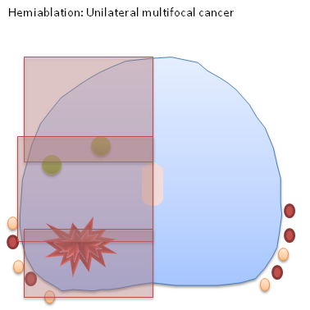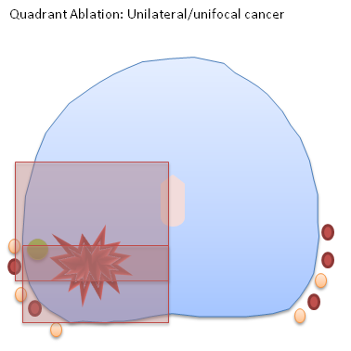

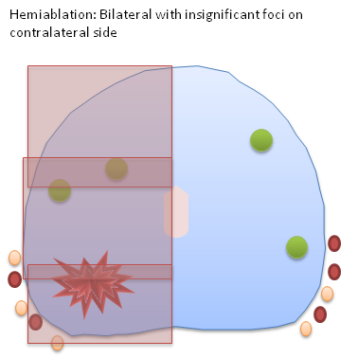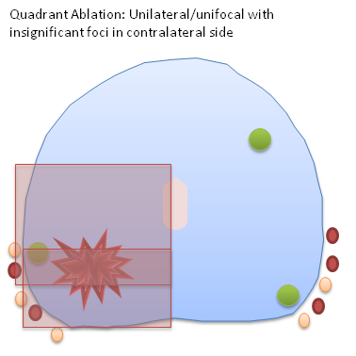

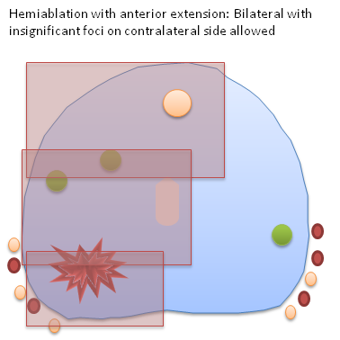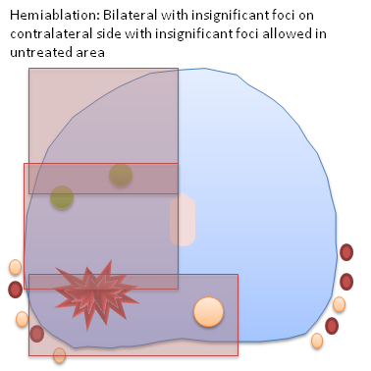

This trial will look at treating about 150 men in this way across several centres. These centres are already familiar with treating prostate cancer with HIFU. The trial will try to find out whether the results of small trials that have already been carried out can be repeated across lots of other centres. The trial will also try to find out if patients remain free of clinically important cancer up to 3 years after focal therapy. If the results are acceptable, then this trial may lead to a change in practice or it may be used to plan and justify a larger trial with longer follow-up.

This is an experimental form of treatment that is not standard practice. Your doctors will discuss other options with you in detail so that you can make a decision about whether to take part in this clinical trial.

The prostate will be treated with a new technology called High Intensity Focused Ultrasound (HIFU). This uses ultrasound waves that are converted into energy when focused on a small area, and can be used to kill cancer tissue. However, this is not the only energy source that can be used to treat focal areas of the prostate. Other energy sources are cryosurgery (freezing), photodynamic therapy (light activated drug), brachytherapy (radioactive seeds inserted into the prostate) and photothermal therapy (heat). We have chosen to use HIFU in this trial because we have a lot of experience in using this energy source and we have used this in the early trials. However, the other technologies are also possible, and they may be used in other focal therapy clinical trials in the UK or other countries.

2. What is High-intensity Focused Ultrasound?

HIFU uses sound-waves to heat small areas of tissue and has been used to treat men who do not want active surveillance, or radical treatments such as radiotherapy or whole prostate surgery. It is a day case, minimally-invasive treatment which does not involve cuts or needles and therefore carries less risk when compared to the conventional therapies already available. The areas to be treated can be as small as a grain of rice and can be carefully located within the prostate to avoid the delicate structures (nerves and muscles that control erections and urine flow) that lie next to the prostate gland.
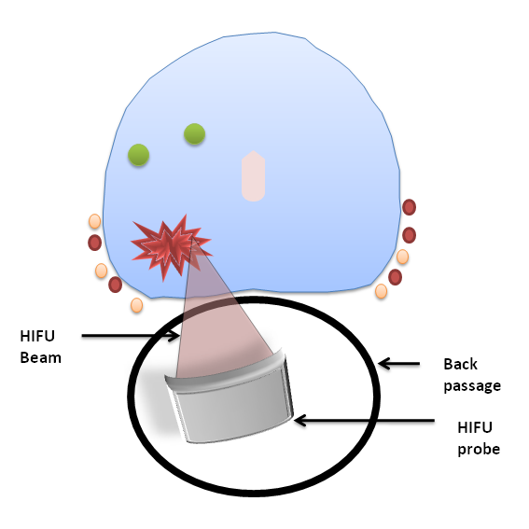

HIFU has been used to treat the whole prostate for 10-15 years. Studies have shown that HIFU whole gland therapy is at least as safe as other treatments for early prostate cancer and has fewer side effects. It also appears to be effective at controlling prostate cancer following treatment, though the studies that show this have a shorter follow-up time. This means that the longest period of time between HIFU whole gland therapy and the assessment of side effects and cancer control is 5-8 years. Whilst this may sound like quite a long time it is generally agreed that 10 to 15 years needs to pass before we can be reasonably sure that any one prostate cancer treatment is as effective as any other. These studies show that HIFU whole gland therapy, in the medium term, appears to be a promising treatment. Depending on the study, and exactly how success was measured, reports have shown that HIFU whole gland therapy was effective at controlling prostate cancer in 80% to 95% of men treated. We think that it is appropriate to use HIFU in this study for these reasons.

These figures are about whole-gland treatment of the prostate. The medium and long-term cancer control of focal therapy is not known. This trial will help us to answer this for medium term cancer control.

Am I eligible for HIFU in this study?

We look at the following characteristics of your individual case before making a decision about whether HIFU is suitable for you:
i. You have localised prostate cancer with a Gleason grade of 7 (3+4 or 4+3) or less
ii. Your PSA is 15ng/ml or less
- You have cancer that has been assessed as localised to the prostate
- If you have only had the standard 10 or 12 biopsy diagnostic test you will need to undergo MRI and Template Prostate Mapping before we can say whether you are eligible for treatment in the trial.
- If on MRI and Template Prostate Mapping, your cancer is located in the prostate in one of the following ways:
- All of the cancer is on one side of the prostate
- The clinically important cancer is only on one side
- There is clinically unimportant disease on both sides of the prostate but one side has a larger amount than the other.
v. The cancer is within reach of the HIFU sound-waves (we assess this measuring the cancer location on MRI or ultrasound).
vi. Calcification (small stones or ‘grit’) in the gland can make HIFU less effective by stopping the sound waves. Using an ultrasound scan, we may need to assess the location and size of the calcification to make sure it does not interfere with the HIFU beam.
vii. Using an ultrasound scan, we may need to assess if the gland has fluid-filled areas (cysts) that will interfere with the ultrasound beam.
- You must have a life expectancy of at least 10 years
- You must be able to read, understand and sign a consent form.
- You must agree to take part in study visits, tests, questionnaires and treatments

In addition, patients with the following criteria will not be treated with the Sonablate® 500:

i. Men who have had radiation therapy, prostatectomy, HIFU or cryosurgery for prostate cancer
ii. Men who have had hormone treatment within the previous 12 months
iii. Men with evidence of disease that has spread outside of the prostate to local lymph nodes and/or beyond (metastases)
iv. Latex allergies make you ineligible for HIFU as the probe is covered with a latex sheath before we insert it into the back passage.
v. if you have a narrowing in your water passage (urethral stricture) or have any metal implants or stents in the urethra you will be ineligible.
vi. Men who have had previous prostate surgery for symptoms (including TURP, Thermal or Microwave therapy within 6 months of the trial screening date) are not eligible
vii. Men with an inability to tolerate a transrectal ultrasound
x. Men who have undergone previous back passage surgery that makes the HIFU high risk (this depends on the type of surgery and an individual decision will be made).

xi. If you have a pacemaker, metal implants, prostheses, clips, or renal failure that prevents you from having an MRI scan of the prostate, you cannot take part in this trial.
xii. Men who are not fit for a general anaesthetic as decided by a Consultant Anaesthetist.

3. Why have I been invited?

You have been chosen because you have had a diagnosis of prostate cancer. The cancer seems not to have spread outside the prostate and the area of tumour may be suitable for HIFU focal treatment. The research team, upon looking at your results, think that you may be suitable for treatment which aims to destroy only the important or dominant areas of cancer and leave non-cancer and unimportant areas of cancer alone. However, there are other treatments that are standard practice and which you may be suitable for. Your doctors will have explored these other treatments with you so that you can make a decision whether you wish to take part in this experimental form of treatment.

4. Do I have to take part?

No. It is up to you to decide whether or not to take part. If you do, you will be given this information sheet to keep and be asked to sign a consent form. You are still free to withdraw at any time and without giving a reason. A decision to withdraw at any time, or a decision not to take part, will not affect the standard of care you receive.

5. What will happen to me if I take part?

If you decide to take part in the trial, you will be asked to attend study visits over the course of the next three years. The precise commitment this will involve is laid out below. After this period, your care will continue in the same way as if you had not taken part in the study. Your progress and condition will be monitored by your doctors in the urology or oncology clinic in the same way that it would have been if you had decided against taking part in the trial.

The flowchart below gives a summary of what this study involves.
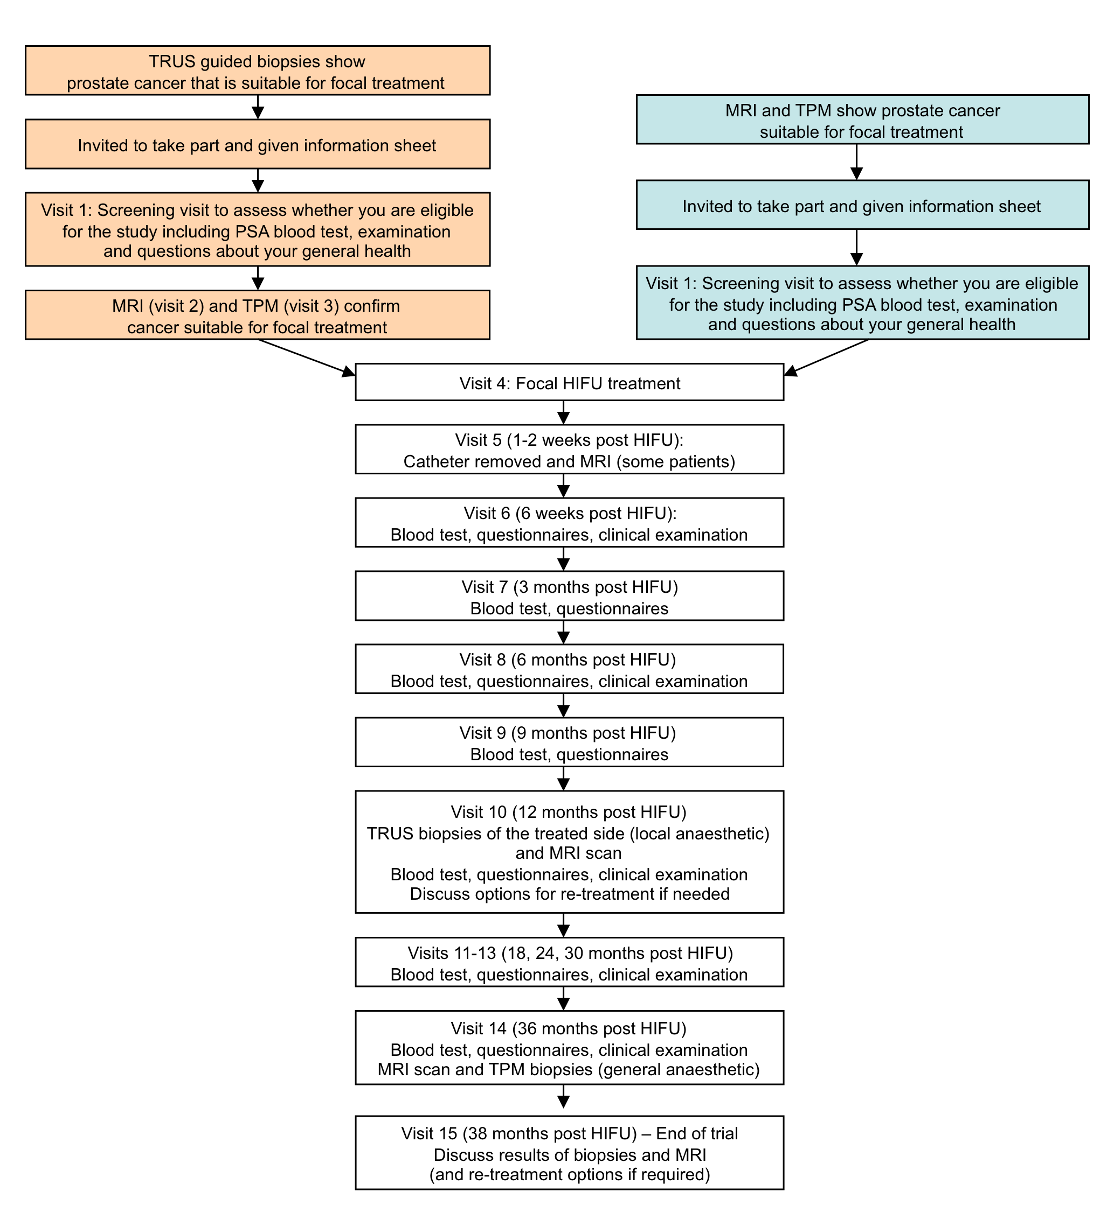
TRUS = Transrectal ultrasound (for prostate biopsies taken via the back passage)
TPM = Transperineal template mapping biopsies

Many of these visits can be telephone consultations by the trial team with blood tests done with your local general practitioner (GP), if your trial hospital is happy with this plan. These include the 3, 9, 18, 30, and 38 month visits. In this case, the questionnaires will be emailed or posted to you with stamped addressed envelope for return to the trial team. We will also ask you to have blood tests taken at 15, 21, 27 and 33 months with your GP.

6. What happens exactly at each visit is outlined below

Screening Visit
Your research doctor will see you as an outpatient, explain the procedure to you, and answer any further questions that you might have. You will be asked to sign a consent form before we carry out anything further as part of the study. By this stage, you may have had TRUS biopsies that suggest you are eligible for the trial. However, you will then need to have an MRI and template mapping biopsies to confirm that you are eligible. If these tests show that you are not eligible, the other treatment options will be discussed with you. Some men will have already had the MRI and template mapping biopsy tests by the screening visit, and if assessed as eligible at this visit, arrangements will be made for your HIFU treatment.

We will ask for the following things as well:
- Questionnaires to complete. These will include questions of a personal nature relating to erectile/sexual function, urinary flow/continence and your quality of life. You will be free to complete these in privacy.
- Blood PSA tests if necessary (if you have not had one done within 60 days of the trial visit). The amount of blood taken will be 5mls. This is about the same as a half a tablespoon of blood.

HIFU Focal Ablation Treatment
- You will be asked to not eat anything for at least 6 hours before the procedure. You should NOT drink anything for at least 4 hours before the procedure. On the morning of the procedure you will be given an enema to clear your rectum. This allows us to have clearer ultrasound pictures during HIFU treatment.
- An anaesthetist will explain the anaesthetic options available to you and make sure that your preferred option is both appropriate and safe. The anaesthetic will usually be a general anaesthetic (which puts you into a deep sleep during which you cannot feel anything). This is so that you do not move during the procedure so that the HIFU treatment is effective. The HIFU focal ablation will use a probe, slightly larger in size to the one used when you had your very first prostate biopsies taken that is placed into the rectum. The treatment normally takes between 1 1/2 to 2 hours.
- Before starting the treatment, a urinary catheter (a tube that drains urine from the bladder) is placed in the bladder. This is usually placed through the skin directly into the bladder rather than through your penis. It will require a 1cm cut in the skin for the tube to be placed. This tube can feel uncomfortable and unusual to pass urine through.
- Once the HIFU treatment is complete your anaesthetist will wake you up. Most men will be able to have their treatment and go home about three to four hours later, provided there is someone to escort them and stay with them overnight. Occasionally, there will be the need for an overnight stay after treatment if your medical team think it is safer.
- You will be taught all about your catheter and how to look after it. Mild pain killers and a 7 day course of antibiotics will be provided. A contact number will be given if you have any problems at home.

Removal of Catheter (5-21 days) and MRI scan (day 5-21) after HIFU Treatment
The MRI scan will allow us to see how successful the destruction of prostate tissue was. Your catheter will be removed if you are passing urine successfully. We will try to organise these two on the same day if possible, but sometimes they have to be done on two separate occasions. You may have the removal of the suprapubic catheter locally if you live far and if a practice nurse or your local urology department nurse is happy to do this. The catheter removal is a simple procedure that is not painful although it may be uncomfortable.

We may have to teach you the technique of Clean Intermittent Self Catheterisation (CISC) if we think the catheter should be removed but you may have problems with emptying your bladder properly. Although this may sound difficult to perform, most people learn it very quickly. It involves you passing a small slippery soft plastic tube (the catheter) into the bladder to empty it and then removing the catheter once the bladder is empty. You would only do this when you needed to. With time your bladder would start to work again and your need for CISC would become less and less.

If you cannot re-establish normal bladder emptying a cystoscopy (using a telescope to look into the bladder) will be carried out to investigate the cause. Some men, about 1 in 50, may need this to be done. At the time a small procedure may be performed in order to improve normal bladder emptying. This might involve releasing some scar tissue in the prostate (formed as a result of the HIFU therapy) or cutting through the tight bladder neck in order to allow more of the bladder to empty. Very occasionally some dead tissue or debris within the prostate would have to be removed. These procedures can be done using a telescope and should require no more than a one night stay in hospital. If you need these procedures, they will be explained to you in detail at the time and your consent will be required.

6 weeks after focal HIFU treatment
- Blood test to measure PSA. Other blood tests may be necessary but are not always required
- Urine test if necessary
- You will be asked about any symptoms that you experienced following the therapy.
- Complete the same questionnaires that you completed prior to the HIFU therapy.
- You will be asked about any new treatments that you have undergone or started since we last saw you

The 3 month follow-up can be a telephone consultation and a PSA test at your GP.

6 months after focal HIFU treatment
- Blood test to measure PSA. Other blood tests may be necessary but not required
- Urine test if necessary
- You will be asked about any symptoms that you experienced following the therapy.
- Complete the same questionnaires that you completed prior to the HIFU therapy.
- You will be asked about any new treatments that you have undergone or started since we last saw you

The 9 month follow-up can be a telephone consultation and a PSA test at your GP.

12 months after focal HIFU treatment
The only difference between this visit and the visit at 6 months is that we will need to do another MRI scan to assess the treated area and take further biopsies of the treated area of the prostate. Biopsies are taken to be as sure as we can that there is no cancer in the treated area. We will not biopsy the untreated areas unless the MRI shows other areas in your prostate that have worrying features and were not present prior to treatment. The biopsy is done under local anaesthetic using an ultrasound probe into the back passage in a similar way to those biopsies you had before the trial to diagnose the cancer in the first place. You will not normally need to stay in hospital overnight. The procedure lasts for 15-20 minutes and you will be given a course of antibiotics to ensure infection does not develop.

The 18 month follow-up can be a telephone consultation and a PSA test at your GP

24 months after focal HIFU treatment
This visit will be identical to the visits at 6 weeks and 6 months.

The 30 month follow-up can be a telephone consultation and a PSA test at your GP

36 months after focal HIFU treatment
At this visit we will ask you to have another MRI scan to assess the success of the treatment. Biopsies will also be taken under general anaesthetic, in the same way as the biopsies you will have had prior to the HIFU treatment, in other words, Template Mapping Biopsies. We will biopsy the whole prostate on this occasion. This is to ensure that there is no significant cancer tissue present anywhere in the prostate. The biopsies will be taken with you asleep and using a template on the skin and an ultrasound probe in the back passage. The biopsies will be taken through the skin around the back passage area. You will need to stay in hospital overnight. This will need to be done at the treating centre.
This visit will also involve blood tests, clinical examination, and questionnaires.

38 months after focal HIFU treatment
You will be told the results of your MRI scan and biopsies. If you need further treatment if these results show recurrent or untreated cancer, the options can be discussed with your doctor at this time. Any treatment that you will have after this time will not be performed as part of the study. Arrangements for your continued follow-up with the appropriate urology team will be discussed at this final visit regardless of whether you need more treatment or not. This visit can also be arranged as a telephone consultation if preferred.

Additional Tests
You will also be asked if you are happy to provide additional blood and urine samples. We wish to take up to 30ml of blood (approximately 6 teaspoons). These samples will be taken at your consent and screening visit, and again at 12 months and 36 months after HIFU treatment. These additional tests will be used to find out more information about prostate cancer. They will not have any influence on your treatment or follow-up. You do not have to agree to have these additional tests if you do not want to, and this will not effect your inclusion within the trial. You will be asked if you are happy to provide these additional samples when you sign the consent form.

7. What will happen once the trial finishes?

Longer-term follow up will be carried out in the form of routine clinical appointments. This would be similar to the follow-up that you would expect to receive if you had chosen active surveillance at the outset.

8. What will happen to me if the treatment fails?

The focal therapy outlined here may fail if side-effects such as urine incontinence or poor erections occur. The HIFU therapy can also fail locally because the treatment was not effective in destroying the area of cancer fully. This will be shown by the MRI scans after treatment and the biopsies carried out at twelve months and three years. Rises in PSA blood tests may also occur if the treatment has failed within the prostate.

We have found that 1 in 10 men may need a further HIFU treatment to the area that has been treated. Should this be the case, we will offer you one further HIFU treatment to the affected area.

You may choose to not have this, other treatment options will be discussed which might include: whole-gland treatments (surgery, radiotherapy, cryotherapy, HIFU), hormonal treatment, or active surveillance/watchful waiting. You will be given detailed information on this.

Focal therapy can also fail if the disease has spread outside the prostate. This can be shown up by a positive bone-scan or by the MRI scan or by a rising PSA. This can cause side-effects of widespread disease including bone pain, weight loss, tiredness/lethargy and fractures of bone.

If this occurs, further treatment options will be discussed with you and might include watchful waiting or hormonal treatment.

9. What data will be collected?

All clinic visit information including questionnaires, scans, biopsy results and blood results will be kept in study records so that we can analyse how this HIFU treatment has performed.
We will hold information about you without anything that could identify you to that data. You will be given a study number and this will used on all your study records. The code for this number will be known to Professor Mark Emberton, Mr Hashim Ahmed, Miss Louise Dickinson and another nominated doctor at the trial centre at which your treatment is given. By using a study number, the link between your name and the data we hold on you is not completely broken.

10. What do I have to do?

You may continue to take your regular medication or other prescribed over-the-counter drugs. You should not be involved in any other studies that involve the prostate gland. Normally, you should not be involved in any other type of study using drugs or medical devices. Please discuss this with your research doctors and they will advise you. It is important that you attend all visits, undergo all study investigations and agree to fill in all questionnaires before and after the treatment. If you think that this may not be possible, then you should discuss this with your doctor. If you hold private medical insurance, you should inform your insurance company that you intend to take part in the study.

11. What is the device or procedure that is being tested?

The procedure we are testing is destruction of only the area of the prostate that contains either clinically important cancer or has the dominant amount of low risk cancer. This treatment will be carried out with a device called the Sonablate® 500 HIFU machine. It uses a high energy focused ultrasound beam (soundwaves), which is directed across the wall of the back passage into the prostate to heat and destroy a very precise volume of tissue at its focus. This study will help us to find out just how safe and well-tolerated HIFU is in destroying only the cancer areas of the prostate.

12. What are the alternatives for treatment?

At the time of diagnosis, prostate cancer may be confined to the prostate itself, or may have spread to other sites within the body. If prostate cancer is confined to the prostate and is amenable to curative therapies then there are a number of treatments available. The types of treatment that aim to destroy the whole prostate include surgery (radical prostatectomy), external beam radiotherapy, brachytherapy (small implanted radioactive seeds), cryosurgery (freezing) or HIFU. Surveillance is also possible if the cancer is low risk. This means watching the cancer and giving treatment if the disease shows signs of progressing. The men who are suitable for this trial will all have low and medium risk disease, which is most often suitable for curative treatment. However, if the cancer is subsequently found to be unsuitable for curative treatment and is progressing but still confined to the prostate then the options are watchful waiting and hormone therapy. This might be discovered on template biopsies at the start of the study. Hormone treatments do not attempt to cure prostate cancer, but treat the side-effects and delay the progression of the cancer. Your doctors will explain which standard treatments are suitable for you.

The treatment outlined in this information sheet is experimental and is not standard practice.

13. What are the side effects of any treatment received when taking part?

Complications from HIFU using the Sonablate® 500 HIFU
Most patients report temporary urinary symptoms (frequency, urgency, difficulty in urination) during the first 2-3 months after treatment. Other complications are listed with the chances of them happening in brackets:
- Urinary tract infection (1 in 20)
- Urethral stricture (narrowing in the urine passage) (1 in 50)
- No semen produced during ejaculation (dry climax) (1 in 2)
- Reduced amount and quality of semen during ejaculation in those men who do have wet ejaculation
- Reduced fertility even if semen is produced
- Epididymitis (infection of the tubes surrounding the testicles) (1 in 100)
- Urinary retention requiring surgery (1 in 100)
- Impotence (1 in 20)
- Urinary incontinence (leakage requiring pads) (1 in 100)
- Recto-urethral fistula (an abnormal connection between the rectum and urinary passage (1 in 500)

These complications are from results using HIFU focal therapy from small trials.

We believe that using HIFU to treat only some parts of the gland may mean less complications and this is what we want to prove in this larger trial. We will only know the true extent of complications after the study results have been analysed. If you have a repeat focal therapy treatment, then the side-effect rates are likely to be higher. We do not know exactly by how much as there is not much experience in this.

14. What are the other possible disadvantages and risks of taking part?

Complications from the Contrast-agent Gadolinium during the MRI Scan
Gadolinium contrast is a solution injected into the vein to make cancers appear more clearly on the MRI. The use of gadolinium is very safe and widely used in clinical practice and not just for this study. Some complications occur and include:
- nausea and vomiting (less than 1 in 2,000)
- mild allergic reaction (e.g., rash, itching) (less than 1 in 250)
- moderate allergic reaction (less than 1 in 2,000)
- severe allergic reactions (breathing problems, face swelling) (less than 1 in 10,000)

Complications from General Anaesthetic

There are risks associated with undergoing any anaesthetic procedure.
- Nausea/vomiting after anaesthetic (less than 1 in 10).
- Most men will have a dry cough for an hour or two and may experience a sore throat for 24 hours. This occurs because a mask and /or tube are placed in the throat during the anaesthetic.
- Minor bruises from intravenous catheters (drips) are common.
- Occasionally extensive bruising, temporary hardening of the vein (phlebitis) or infection can occur from intravenous catheters (1 in 20).
- The known risk of death under anaesthesia in the UK is 1 in 150,000 anaesthetics. To put this in perspective, if we anaesthetised a volunteer every day for 400 years there would be one death.

Complications from Transperineal Template Mapping Prostate (TPM) Biopsies
These include:
- Bloody urine for up to 48 hours (most men)
- Bloody semen for up to 3-4 months (most men)
- Bloody urine requiring admission to hospital with catheter tube drainage and washout of the bladder (1 in 50)
- Retention of urine requiring a temporary catheter (1 in 20)
- Prostatitis (inflammation or infection of the prostate, less than 1 in 100)
- Temporary pain/discomfort in the anal area (most)
- Temporary problems with erections for up to 6-8 weeks (most men)
- Infection requiring admission and intravenous antibiotics (rare)

Complications from Transrectal Ultrasound Guided (TRUS) biopsies
These include:
- Bloody urine (1 in 100)
- Bloody semen (1 in 100)
- Retention of urine requiring a temporary catheter (1 in 100)
- Prostatitis (1 in 100)
- Anal pain (less than 1 in 200)
- Urine infection (2-4 in 100)
- Infection requiring admission and intravenous antibiotics (1 in 100)

Complications of having a Suprapubic Catheter
These include:
- Discomfort (most)
- Infection of the wound site (1 in 100)
- Pain around the wound site (1 in 20 to 1 in 50)
- Urine leakage through the wound during or after the suprapubic catheter is removed (1 in 20)
- Injury to bowel requiring an open operation (rare)

If, during the course of this trial, we were to discover a condition of which you were unaware, we will inform you, and if necessary refer you to the relevant medical practitioner. If you have private medical insurance you should check with the company, before agreeing to take part in the trial, whether participation is considered a ‘material fact’ that should be reported. You will need to do this to ensure that your participation will not affect their medical insurance.

Please share this information with your partner if it is appropriate: it is not known if the study device will affect sperm or semen. It is possible that the sperm quality could be affected by participation in the study. You should not assume that you will be infertile as the majority will not be affected. We are hoping that ejaculation will be maintained.

15. What are the possible benefits of taking part?

The possible benefits from this treatment are that we may be able to treat only the part of the prostate that contains significant areas of cancer and therefore eliminate any active cancer tissue and reduce the risk of disease progression with fewer side-effects. We hope that you will personally benefit from HIFU therapy. However, this cannot be guaranteed. There may be a number of disadvantages to you by taking part in the trial, which are explained in section 8.

The treatment may not treat all of the cancer, or you may have recurrence of the cancer later on requiring further treatment.

The information provided in this information sheet should help you to decide whether you wish to undergo this experimental form of HIFU treatment.

16. What happens when the research study stops?

When the research study is completed, the results will be analysed. If the treatment has been shown to be useful, the next step would be to compare the longer-term results of HIFU focal ablation treatment with other standard treatments such as radiotherapy, surgical removal of the prostate, or active surveillance in a larger clinical trial.

17. What if there is a problem?

Any complaint about the way you have been dealt with during the study or any possible harm you might have suffered will be addressed. The detailed information on this is given in Part 2. A contact number for complaints is given in Part 2.

18. Will my taking part in the study be kept confidential?

Yes. All the information about your participation in this study will be kept confidential. The details are included in Part 2.

19. Contact Details

In the first instance, for further information or any concerns during the study, please contact

Name xxxxxxx (Trial Research Nurse, own hospital)
Tel:
Email

OR

Miss Helena Stone or Miss Jane Coe (Trial Research Nurses, University College Hospital London)
Tel: 0203 447 7364 or 0203 447 4932 or 07527 961138
E mail: Jane.Coe@uclh.nhs.uk or Helena.Stone@uclh.nhs.uk

OR

Miss Louise Dickinson (Trial Doctor and Co-ordinator, University College Hospital London)
Tel: 0203 447 9194 (via Professor Emberton’s secretary)
E-mail: Louise.Dickinson@uclh.nhs.uk

You may also contact the Urology Consultant (via his office) or Nurse Practitioners of your hospital. The details will be given to you.

In an emergency it is best to contact your local GP or go to your local Casualty department or dial 999 for an ambulance. It is important that your GP and local hospital know whom they should contact for further information. Therefore, if possible in such a situation please take the above contact details with you.

This completes Part 1 of the Information Sheet. If the information in Part 1 has interested you and you are considering participation, please continue to read the additional information in Part 2 before making any decision.

Part 2

20. What if relevant new information becomes available?

Sometimes during the course of a research project, new information becomes available about the treatment that is being studied. If this happens, your research doctor will tell you about it and discuss whether you want to or should continue in the study. If you decide not to carry on, your research doctor will make arrangements for your care to continue. If you decide to continue in the study you will be asked to sign an updated consent form.
Also, on receiving new information your research doctor might consider it to be in your best interests to withdraw you from the study. He/she will explain the reasons and arrange for your care to continue.
If the study is stopped for any other reason, you will be told why and your continuing care will be arranged.

21. What will happen if I don’t want to carry on with the study?
Your participation in the trial is entirely voluntary. You are free to decline to enter or to withdraw from the study any time without having to give a reason. If you choose not to enter the trial, or to withdraw once entered, this will in no way affect your future medical care. All information regarding your medical records will be treated as strictly confidential and will only be used for medical purposes. Your medical records may be inspected by competent authorities and properly authorised persons, but if any information is released this will be done in a coded form so that confidentiality is strictly maintained. Participation in this study will in no way affect your legal rights.

22. What if there is a problem?

If you are harmed by taking part in this research project, there are no special compensation arrangements. If you are harmed due to someone’s negligence, then you may have grounds for a legal action but you may have to pay for it. Regardless of this, if you wish to complain, or have any concerns about this study, the normal National Health Service complaints mechanisms should be available to you.

If you have any comments or concerns you may discuss these with the investigator. If you wish to go further and complain about any aspect of the way you have been approached or treated during the course of the study, you should write or get in touch with the Complaints Manager of your hospital or the sponsor (University College London).

23. Will my taking part in this study be kept confidential?

Our procedures for handling, processing, storage and destruction of their data are compliant with the Data Protection Act 1998.

Your data will be collected at each visit. Blood and biopsy results will be collected from UCLH NHS Trust computer database and your medical notes. The data will be held in both paper form and on secured laptop computers at both your hospital’s site and the site of the trial sponsor hospital i.e. UCLH.

The data will be stored securely, in a coded manner so that no information that could identify you is held in study records. The controller for this data is UCLH NHS Trust. The custodian of this data who is responsible for the safety and security of the data is Professor Mark Emberton (Chief Investigator).

The data will be analysed and any results may be published in medical journals. The data will also help us plan larger trials using this form of HIFU treatment if it is successful. If the data is to be used in any other way in future studies then approval will be sought from the local Research Ethics Committee.

The following persons will have authority to view identifiable data:
- Professor Mark Emberton (Chief Investigator)
- Mr Hashim Uddin Ahmed (Co-investigator, Clinical Research Fellow and Urology Registrar)
- Miss Louise Dickinson (Trial Co-ordinator, Clinical Research Fellow and Urology Registrar)
- The trial doctors and specialist nurses (co-investigators) within your own hospital

The data will be retained for at least 3 years after the end of the study. All information that is collected about you during the course of the research will be kept strictly confidential. Any information about you that leaves the hospital/surgery will have your name and address removed so that you cannot be recognised from it.
Sometimes the pictures taken during the HIFU treatments are reviewed by the manufacturers of the Sonablate 500 HIFU machine for quality control and auditing purposes. This is normal practice, even in men having HIFU treatment that are not involved in a trial. Only authorised personnel will look at this information and your details will be kept strictly confidential.

24. Involvement of your General Practitioner/Family doctor (GP)/Other Doctors

With your consent, your GP and other doctors not involved in the research but looking after you in this or another hospital will be notified of your participation in this study. If you will not consent for this then we cannot enter you into the trial as it is important that these doctors are aware of what treatment you have had for the prostate.

25. What will happen to any samples I give?

The trial PSA blood samples will be processed in the hospital laboratories as part of routine anaesthetic work-up or for follow-up after treatment. Samples are not kept for more than 2 days in the laboratory and no further tests are carried out on them. All these blood tests would occur if you were to undergo surgery or radiotherapy and are not extra samples taken just for this study.
The prostate biopsies you have taken will be processed and reported by the Department of Histopathology at your hospital. Some will also be reported at another trial hospital e.g. UCLH, to be extra sure that we have the right information. After the biopsies are reported by a Consultant Histopathologist, this study will make no further use of the samples. We view your samples as a ‘gift’ which will be stored in the Histopathology department with your hospital number, name and date of birth. This means that your samples may be used in other research in the future, but this will only be carried out with Research Ethical Approval by an Ethics Committee.
If you agree to have additional blood and urine samples taken, these will stored within a secure biobank at the Royal Free Hospital site. They will be stored anonymously so that your name is not associated with the samples and only authorised research persons will have access to them. Future studies, including genetic studies, can only be carried out on the samples with approval from the Research Ethics Committee. If such approval is gained the Ethics Committee may insist that those future researchers seek your permission if the committee considers that the study is likely to substantially affect your interests.

26. Will any genetic tests be done?

No genetic studies will be carried out as part of this study, but future work in this area may be performed if separate ethics approval is requested and accepted.

27. What will happen to the results of the research study?

The results of the study will be analysed and presented as publications for medical journals and at scientific meetings around the world. There will be no identifiable data in these publications. A summary of these results will be available for you and copies of full publications will also be available if you wish to have them.

28. Who is organising and funding the research?

The University College London Hospitals NHS Trust is sponsoring the study and is responsible for making sure it runs according to best research practice and relevant laws of the United Kingdom. The funding for this trial is being supported by a commercial American company called USHIFU. Funding is available only for those tests and treatments beyond what is normally given during any other standard treatment that you could have had. Funding is not available for travel expenses. The involvement of a commercial group will have no impact on your care and will be exactly the same as if the trial was fully sponsored by a public body.

29. Who has reviewed the study?

The study has been reviewed by independent peers, who are doctors familiar with this type of treatment. Their suggestions have been included in the study plan. Ethics approval for the study has been sought and a favourable outcome given by the South-East Research Ethics Committee.

A copy of this Information Sheet will be given to you and if you decide to participate, a copy of the signed consent form will also be given. Please feel free to ask any questions to the Research Staff. Many thanks for taking the time to read this Information Sheet and considering taking part in our Study.

Contact Details

Local centre contact details:

Trial nurse Trial doctor
Tel: Tel:
E mail: E mail:

Sponsor site (University College Hospital London) details:

Professor Mark Emberton

Consultant Urological Surgeon/ Trial Chief Investigator

Tel: 0203 447 9194 (Professor Emberton’s secretary)

Miss Louise Dickinson

Clinical Research Fellow / Trial Co-ordinator

Tel: 0203 447 9194 (via Professor Emberton’s secretary)
E-mail: Louise.Dickinson@uclh.nhs.uk

Miss Helena Stone
Trial Nurse
Tel: 0203 447 7364 or 07527 961138
E mail: Helena.Stone@uclh.nhs.uk

Miss Jane Coe
Trial Nurse
Tel: 0203 447 4932 or 07527 961138
E mail: Jane.Coe@uclh.nhs.uk

